
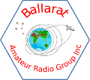

BARG News

Ballarat Amateur Radio Group
Inc. #6953T
February
Monthly Newsletter

Next Meeting
Saturday 23th of February 2019 @ 11:00am

At the B.A.R.G. Club House, Ballarat Airport

All Welcome

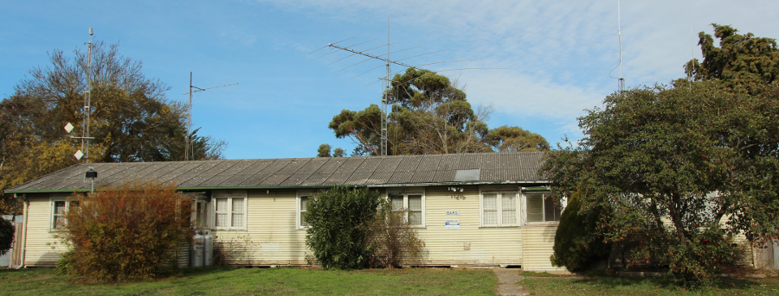
Contacting us
You can write to the club at the address below, or e-mail the secretary

The Secretary : B.A.R.G. Inc.
Box 1218
Mail Centre
Bakery Hill Vic. 3354

Or E-Mail : vk3bml@barg.org.au

We’re on the web
www.barg.org.au

Presidents Report
Welcome to the February newsletter.
Till next time,
Malcolm, VK3OAK

VHF and Above for February 2019

In the past few weeks propagation has declined with little to report other than the usual listed activity.

However since in the last newsletter some of the locals have achieved some results worth reporting. Bob VK3BNC had a very good contact on 1296 with VK3VG in Shepparton with 5x9 signals on SSB so well done Bob.

Craig has also achieved results when he went portable south of Linton with his recently completed 1296 transverter. Tests were done between the portable location and VK3AXH with 5x9 results both ways. Craig was using a Minikits transverter with a FT817 as the I.F. driver. Craig is in the process of building a bigger antenna for portable operation and is hoping to put up 4 loop yagi’s at his home QTH in the near future.

The provisional results for the recent VHF field day have been released and with the assistance of contacts in the 2.4 – 5.7G bands Ian VK3AXH managed a 2nd place in his class. This result was aided by the EMDRC gang using callsign VK3KQ at the Enfield State Forest. Bands used by Ian from his home QTH were from 6m through to 5.7G. Best contact on 2.4G to the other EMDRC setup North of Ballan in the Wombat State Forest.

Paul VK3TXR now has his preamplifier working and hearing signals a lot better as a result. Pauls next adventure is to increase his output power so watch this space for updates.

Bob VK3BNC has been working on his dish for EME and hopes to be in a position to do some testing shortly. As we know it’s one thing getting a dish in place then another challenge to get it all going with a suitable feed, Az/El control, preamps and list goes on.

In the near future the club will hopefully participate in the John Moyle Field Day from the clubrooms. It’s hoped some microwave activity can also be performed from the club rooms or perhaps Mt Hollowback. As ususal we rely on suitable weather for this part of the event.

If you have been doing something in your shack drop me a note so it can be included in the magazine.

Till next time 73 de VK3AXH

12. QST Review December 2018

P13 Member Spotlight. Michael WD4MGP
P24 Correspondence.
P30 Build a Versatile T/R Switch for SDRs and Vintage Radios.
P35 The Hourglass Loop antenna. 2M and 70cm.
P38 Review Yaesu FTM-7250DR Analogue and System Fusion Dualband Transciver.
P41 Build a QRP 20M Transceiver kit.
P44 Review: PWRgate DC Power manager/Charge controller.
P47 Review: SOTABEAMSWSPRite Antenna & Propagation Tester.
P51 The Doctor answers a range of technical questions for you.
p53 Hints & Kinks. Preamp for Dynamic mike, Mobile support
P55 Eclectic Tech looks at the importance of TIME as used in many programs like WJST et al.
P56 Making Digital contacts through the ISS.
P58 About Cognitive Radio. What, How and where to now.
P61 Winter Field day a challenge.
P63 Happenings.
P66 Public Service: Event operating. Top 20 training tips and Techniques.
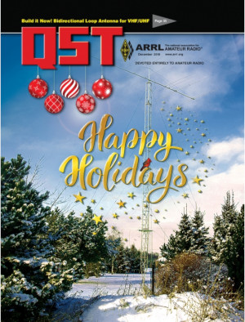
P68 Classic Radio: Pierson-Holt KE-93 mobile receiver. Uses a TV turret tuner with biscuits.
P92 How’s DX?. August 2018 expedition to Central Pacific.
P 94 World above 50 MHz. Effects of Hurricane Flore.

That’s all for this year.
73 Craig VK3KG.

VK3BML club station of Ballarat Amateur Radio Group.

12 SILICON CHIP DECEMBER 2018 REVIEW.

Features and Reviews.
The “Grand Tour” The incredible Voyager missions.
Arduino Uno’s cousins: The NANO and the MEGA.
El Cheapo modules. Part 21 stamp sized audio player.
Construction Projects.

Incredibly sensitive Magnetometer.
Amazing light display from our LED Christmas tree,
A Useless Box.
Low voltage DC motor and Pump controller [Part 2]
Your Favourite Columns.
Serviceman’s Log.
Circuit Notebook.
- Simple practice guitar amp.
- Accurately measure V& I at the same time.
- 1KHz crystal locked sinewave oscillator.
Vintage Radio, Compact model 450P portable from 1948 by AWA.
Everything Else!
Includes a leaflet from Altronics with specials.

THE MILITARY SYSTEM, BY ONE WHO KNOWS.
The Australian way is the simplest way, otherwise it would encroach on drinking time – see, it’s quite simple really.!
A friend once said to me he didn’t understand the military system. Dumb civy !!!
I said the “system” is quite simple really.
You see all privates are soldiers. But not all soldiers are privates. Some are officers who are commissioned, but some are officers who are not commissioned. Those ones however hold Warrants and not a Commision. See its getting easier now.
Its obvious that if every private was called private it would be confusing, so some privates are called things like trooper, driver, gunner,craftsman, sapper or signaller.
Not all the drivers actually drive because some of them cook, but we don’t call them cooks, for that matter, not all drivers are drivers because some are still privates or gunners. Gunners are as I am sure you will know are the blokes [and girls now] that fire the guns, unless of course they are drivers or signallers in which case we call them gunners and sigs just to clarify and keep it simple.
All gunners belong to the artillery, except those in the infantry where we have gunners called privates because they fire a different sort of gun, for the same reason we call our drivers and signallers private as well.
So there you have it, an understanding of how simple the rank structure is in the army.
Next we will look at the navy. On second thought we will leave them alone and stuck up at sea. I never did understand those white shirts and trousers on people as they went into battle. Would show off the blood stains methinks. !

